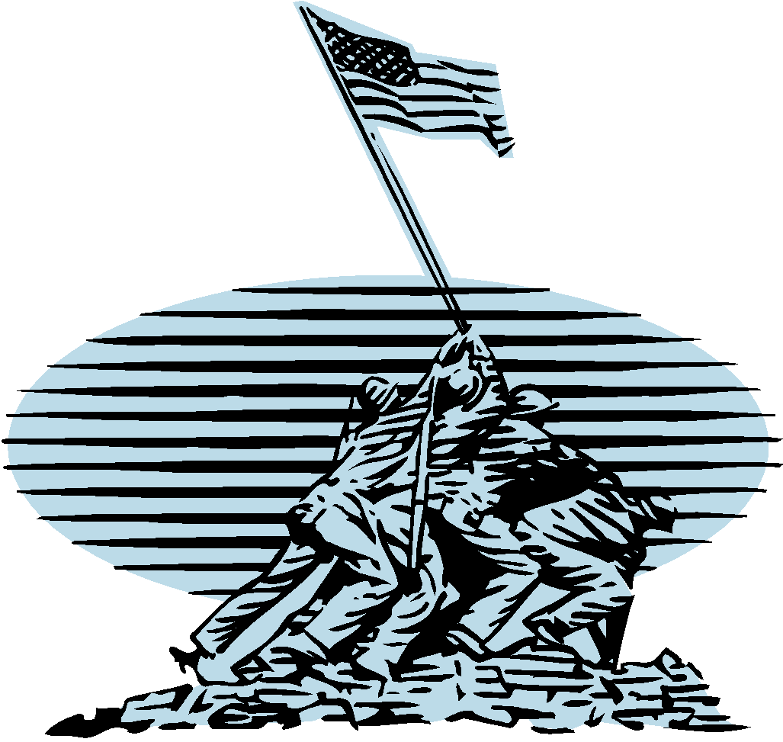
Berrien Springs High School

U.S. History & Geography
Course Syllabus
For: Mr. Ruhl
Room 132
E-mail: rruhl@homeoftheshamrocks.org
School Phone: 269-471-1748
My Cell Phone: 269-470-7092
Prep Period: 5th & 6th Blocks
Class Website: http://ushistoryruhl.weebly.com/

EDUCATIONAL PHILOSOPHY:

Each and every student is an individual, is valuable and unique! Since every student learns in his or her own way and at his or her own pace, it is important that the learning environment support the individual. The purpose of education is to help each and every student find and understand his or her unique talents, gifts, abilities and interests and then use them within society. The purpose of U. S. History is to enable students to become better citizens who are equipped with the skills and knowledge necessary to sustain and improve this country. Through the development of historical knowledge, discussions, debate and critical thinking students will enhance their ability to make educated and calculated decisions.

COURSE DESCRIPTION:

U.S. History & Geography is a one-credit course that is required for graduation.

The purpose of this course is to understand how the events, and successions of events, in the history of the United States have shaped and developed our current society and governmental policies. The class officially begins with the period around 1870 and moves to the present—the primary focus of the class is on the twentieth century. However we will begin our study with a brief review of early U.S. History (which was covered in middle school) and then move into an in-depth study of industrialization and the growth of a modern United States. Students should be able to use their knowledge to understand cause and affect relationships and make wiser choices for the present and future—political, social and economic. Geographical influences and factors effecting U.S. policies and decisions will be explored and evaluated.
COURSE TOPICS:
Students will be able to describe and sequence the following eras of American history, along with the key events, examine relationships, explain cause and effect relationships, and apply their new knowledge to present and future choices. The focus of this class is in bold print.

ERAS
- The Meeting of Three Worlds (beginnings to 1620)
- Colonization and Settlement (1585 – 1763)
- Revolution and the New Nation (1754 – 1815)
- Expansion and Reform (1801 – 1861)
- Civil War and Reconstruction (1850 – 1877)
- The Development of the Industrial United States (1870 – 1900)
- Life at the turn of the Century (19th – 20th)
- The Emergence of Modern America (1890 – 1930)
- The Progressive Period
- Becoming a World Power
- World War I
- The Roaring 20’s
- The Great Depression and World War II (1929 – 1945)
- The Great Depression & the New Deal
- World War II
- Post War United States (1945 – 1970)
- The Cold War
- The New Frontier & Great Society
- The Vietnam War
- The Civil Rights Movement
- Contemporary United States (1968 – present)
- A Search for Order—the 1970’s
- A Conservative Era—the 1980’s
- Into the 21st Century

Classroom Expectations:

- Take Control of YOUR Education – Be in class prepared to accomplish something everyday and bring yourself closer to your goals.

- Do Your Best – while everyone has an off day, students are expected to do their best each day – with the understanding that we are not at our best every day!

- Respect Classmates & Teacher – every person is valuable and important, thus we must do our best to treat one-another with respect and to build one-another up!

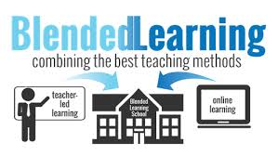
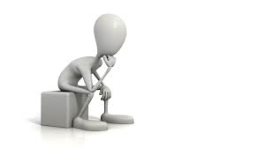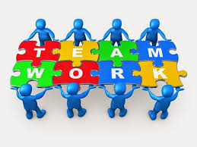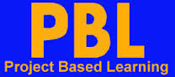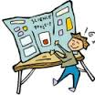
We will be using a blended learning model for all learning within U.S. History this school year. Blended Learning is simply a combination of teacher-led learning with online learning. Within the classroom students will be engaged in a combination of online learning, individual learning, group/team work, project-based learning, small group instruction and some whole class activities. The purpose of blended learning is to allow for much greater individualization of learning—thus allowing each student to learn in his or her own way, and within his or her own timing (to a degree at this time). The KEY to Blended Learning is that the STUDENT is in charge of his or her learning and the teacher functions more as a coach helping each student to be successful, to understand how he or she learns best, and discover how this new knowledge and skills relates to his or her real life.

Grading Policy

Grading Scale:
A+ = 98% - 100% | B+ = 87% - 89% | C+ = 77% - 79% | D+ = 67% - 69%
A = 93% - 97% | B = 83% - 86% | C = 73% - 76% | D = 63% - 66%
A- = 90% - 92% | B- = 80% - 82% | C- = 70% - 72% | D- = 60% - 62%
***** All work 59 and below will be scored at a 50% (F or NTY—Not There Yet)

Formative (Assessment) Grading Policy
All formative work is worth only 10% of the student’s grade and is meant to help the students master the required/expected standards through a process of practice and feedback, practice and feedback, practice and feedback with misunderstandings and failure expected regularly on the road to understanding and success. Formative assessment will consist of various types of practice work at both school and home, online discussions, class assignments, class activities, quizzes, short-term minor projects, and team/group projects. Formative assignments MUST be completed prior to the summative assessment for that unit.

Summative Assessment/Tests
Summative assessment counts for 90% of the student's grade. These tests and assessments are the final measurement of what the student knows and doesn’t know. It is the point at which the student demonstrates his/her level of mastery over the required content/standards. Summative assessment will consist of multiple choice, matching, short answer questions, comprehensive essays, projects and a variety of types of assessment. *Students are expected to retest any failed tests until they have successfully demonstrated understanding and mastery of the unit at which point they may advance to the next unit.

Projects will be used many times to help students understand and apply learned information. Projects can be both short or long term, and be either individual or be done within a group. Most projects are longer term and consist of cooperative learning with other students.

Group Work is a very important part of this class! Students will work in pairs and groups of three, four, and sometimes even more. This is not optional and each student is expected to do his or her part at all times.

Cheating
Any student caught cheating will be expected to redo any work to demonstrate understanding and mastery. Repeat offenders may face stricter consequences.

History PBL, Culminating Activities & Final Exam

- Each student is required to complete one U.S. History PBL (Project-Based Learning) activity
- The “Final Exam” grade will account for 20% of a student’s final grade—the marking period grades account for the other 80%.
- The “Final Exam” grade consists of three parts:
  - The first part is a Performance-Based Culminating Activity—Student Senate Hearing on Foreign Policy & Domestic Issues (accounts for 5% of the exam grade).
  - The second part is a Reflective-Application Essay on major lessons learned and how the new knowledge can be applied in real life (accounts for 10% of the exam grade).
  - The third and final part of the exam grade is a traditional exam multiple choice—general knowledge (accounts for 5% of the exam grade). NO study guide will be given.
- Students must have a final average/grade of a 60 or higher in order to pass the class and receive credit.

- Performance-Based Culminating Activity: Student Senate Hearing on Major Domestic Issues & Foreign Policy (Grades based on quality of preparation & participation).
  - Pre-Hearing Preparation
    - Write: Individual Major Domestic Issue Paper
    - Write: Individual Foreign Policy Position Paper
    - Team Discussion, Planning & Preparation

  - Senate Hearing – Role Play
    - Part I:Presentation of Major Domestic Issues (2 Minute Presentations)
    - Part II: Foreign Policy Group Presentations of Position/Proposal
      - Questions & Challenges from Opposing Positions
      - Final Vote

